Background Information:
Last night a murder was committed in room 313. The victim was identified as a 25 year old, single, female. At 9:00 pm, she was discovered by a maintenance worker. The victim had been shot in the chest and was lying face down when she was found. Before she was removed from the scene of the crime, the position of her body was outlined with tape. None of the other items at the scene were disturbed.

Materials Needed:
Pencils (lead and colored) Ruler
Black pen or marker Blank paper and Graph paper
Prepared crime scene Tape measure

Procedure 1:

- Decide who on the team will do the following: sketch, take notes, measure (2 people)
- Identify all the items in the crime scene that you believe to be physical evidence. Note the taped outline of the victim on the floor.
- Generate a rough sketch of the scene. Remember to measure the dimensions of the space and use these points to accurately characterize the contents of the scene. Remember, your sketches will have to provide enough detailed, accurate information so that it can be useful months or years from now.
- Indicate north on your sketch
- Use squares or circles to represent the locations of different objects
- Label each piece of evidence with a letter.
- For each object, draw a dashed line from one fixed location to that object. Draw a dashed line from another point to the object.
- Write the actual distances above the dashed lines on the drawing
- Label the Sketch with:
- Address or location of scene.
- Date sketch was made and by whom.
- A key to identify the different objects in the sketch.

Procedure 2:
- Use the “rough” sketch you made of the crime scene to draw a polished, final drawing that may be used at trial.
- The final sketch should:
- Be neatly drawn with black ink or marker on a piece of posterboard
- Be drawn to scale (for example: let 1cm = 40 cm of space in the room. A room measuring 6 m by 6 m would be drawn as 15 cm wide and 15 cm long)
- Label north on the drawing
- Draw squares and circles to represent the physical evidence in proportion to each other
- Place the actual length and width of the room on the drawing
- Place the actual distances of the evidence from the fixed points
- Your drawing should contain all the evidence in the rough sketch

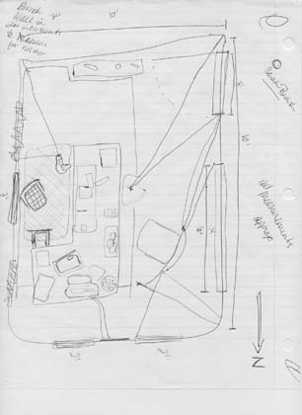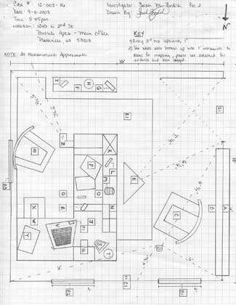
Figure A—An example of a rough Figure B—An example of a final
sketch. Courtesy of Sarah Bedish sketch. Courtesy of Sarah Bedish

- List the physical evidence you believe to be relevant to this investigation in a table following the sketch and make recommendations about how each should be tested (i.e, sent to DNA lab, dusted for fingerprints, taken to lab for toolmark or footprint comparison, etc.)

Analysis Questions:

1. Why were you asked to use fixed points in your drawing?
2. Why do you think you do not make the polished sketch at the crime scene?
3. Who does a sketch artist work with at a crime scene to make sure all details are documented?
4. Identify what changes you would make to your process if the crime scene was outside vs. indoors.

You will turn in the original notes of the scene (photocopied if necessary), the original sketch
(photocopied if necessary), and the finished-sketch diagram of the scene.

Make sure the final sketch is properly labeled with all necessary items. I'll be looking for
direction, measurements, illustration key, neatness, clarity, accuracy, team member names, date,and scale
HAVE FUN!

