[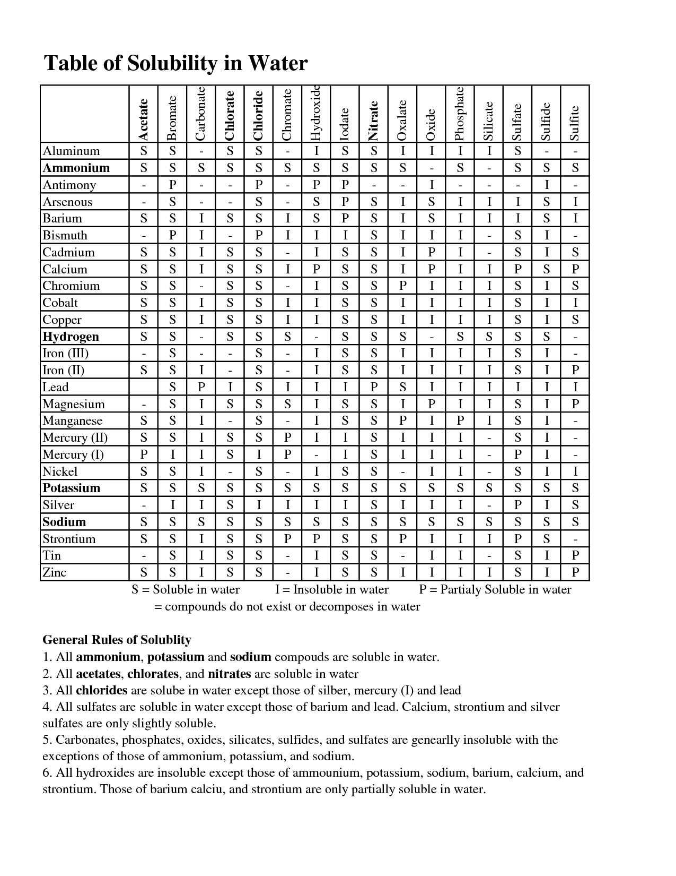](http://www.google.com/url?sa=i&rct=j&q=solubility+chart+in+water&source=images&cd=&cad=rja&docid=6_WG_xT7AR557M&tbnid=BRQVojMC8VrT7M:&ved=0CAUQjRw&url=http%3A%2F%2Fwww.docstoc.com%2Fdocs%2F100751320%2Fsolubility-chart-and-rules&ei=SBg6UfG9KrC70QGqxoGICg&psig=AFQjCNEoxchgyUCXAMbglyfA6jZrq70Etw&ust=1362848152008330)